**----------------------------------------------------------------------------------------------------------------**

**1.4 - Add Event room**

**----------------------------------------------------------------------------------------------------------------**

Set serveroutput on;

create or replace procedure add_event_room(

h_id in number,

r_type in varchar2

)

--Add Event Room: Given a hotel ID, add a new room for a specific event

--to that hotel. The room types are: Small Hall, Medium hall, Large hall.

--@param h_id, the hotels id

--@param room_type, the room_type to add to the hotel

AS

hotel_exists number;

BEGIN

--check that hotel exists

select count(*)

into hotel_exists

from hotel h

where h.hotel_id = h_id;

if(hotel_exists = 1) then

if (r_type = 'Small room') then

update hotel set max_small_room_avail = max_small_room_avail + 1 where hotel.hotel_id = h_id;

dbms_output.put_line('An additional small room is now available for booking for hotel with id ' || h_id);

elsif (r_type = 'Medium room') then

update hotel set max_medium_room_avail = max_medium_room_avail + 1 where hotel.hotel_id = h_id;

dbms_output.put_line('An additional medium room is now available for booking for hotel with id ' || h_id);

elsif (r_type = 'Large room') then

update hotel set max_large_room_avail = max_large_room_avail + 1 where hotel.hotel_id = h_id;

dbms_output.put_line('An additional large room is now available for booking for hotel with id ' || h_id);

end if;

else

dbms_output.put_line('Hotel with id: ' || h_id || ' does not exists' || chr(10) ||

'No table was updated');

end if;

END;

**1.4 Output**

**--------------------------------------------------------------------------------------------------------------------------------**

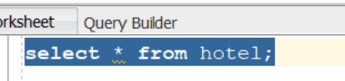



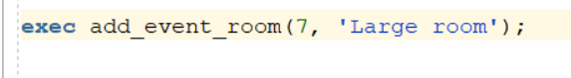





**1.5 - display available rooms**

**--------------------------------------------------------------------------------------------------------------------------------**

create or replace procedure display_available_rooms(

h_id in number

)

--Show available rooms by type: Given a hotel ID,

--display the count of all available rooms by room type.

--@param h_id, the hotel id

AS

small_room number;

medium_room number;

large_room number;

BEGIN

SELECT max_small_room_avail, max_medium_room_avail, max_large_room_avail into small_room, medium_room, large_room from hotel h where h.hotel_id = h_id;

--display all available rooms by type

dbms_output.put_line('Rooms vailable: ' || chr(10) ||

'---------------------------');

if(small_room > 0) then dbms_output.put_line('Number of small rooms available: ' || small_room); end if;

if(medium_room > 0) then dbms_output.put_line('Number of medium rooms available: ' || medium_room); end if;

if(large_room > 0) then dbms_output.put_line('Number of large rooms available: ' || large_room); end if;

EXCEPTION

when no_data_found

then dbms_output.put_line('No hotel with id:' || h_id || ' found.');

END;

**1.5 Output**

**--------------------------------------------------------------------------------------------------------------------------------**

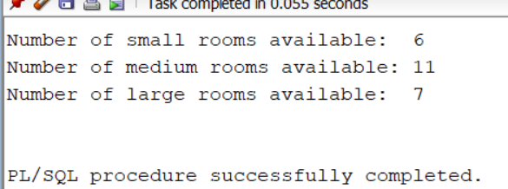

**1.6 - Display hotel event rooms**

**--------------------------------------------------------------------------------------------------------------------------------**

create or replace procedure display_hotel_event_rooms(

hotel_state in varchar2

)

--Report Hotels and Event Rooms In State: Given a state,

--display event room information of all hotels in that particular state.

--Include total capacity per event room type per hotel.

--@param hotel_state, a state in which hotels belong

AS

CURSOR hotel_cursor IS

SELECT * from hotel h where h.state = hotel_state;

capacity_small number;

capacity_medium number;

capacity_large number;

BEGIN

--grab capacity for small, medium and large room types

select room_capacity into capacity_small from room_type where room_type = 'Small room';

select room_capacity into capacity_medium from room_type where room_type = 'Medium room';

select room_capacity into capacity_large from room_type where room_type = 'Large room';

--iterate over all hotels with in state and display their information

dbms_output.put_line('Hotel(s) available in : ' || hotel_state || chr(10) ||

'---------------------------'

);

FOR hotel in hotel_cursor

LOOP

dbms_output.put_line(

'hotel id : ' || hotel.hotel_id || ' (' || hotel.street_address || ', ' || hotel.city || ' ' || hotel.state || ' ' || hotel.zip_code || ')' || chr(10) ||

'Number of small rooms available : ' || hotel.max_small_room_avail || '| with a total capacity of ' || hotel.max_small_room_avail * capacity_small || '(' || capacity_small || ' per room)' || chr(10) ||

'Number of medium rooms available: ' || hotel.max_medium_room_avail || '| with a total capacity of ' || hotel.max_medium_room_avail * capacity_medium || '(' || capacity_medium || ' per room)' || chr(10) ||

'Number of large rooms available : ' || hotel.max_large_room_avail || '| with a total capacity of ' || hotel.max_large_room_avail * capacity_large || '(' || capacity_large || ' per room)' || chr(10) ||

'---------------------------'

);

END LOOP;

EXCEPTION

when no_data_found

then dbms_output.put_line('No hotels within state: ' || hotel_state);

END;

**1.6 - Output**

**------------------------------------------****--------------------------------------------------------------------------------------**

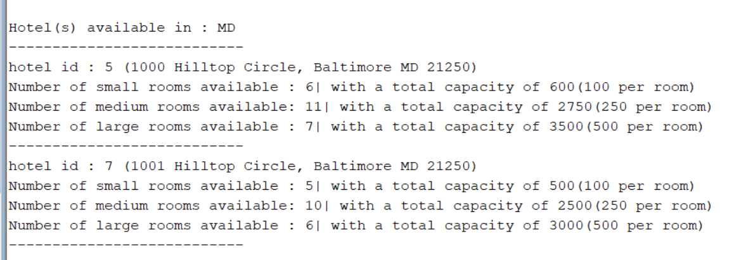

**--------------------------------------------------------------------------------------------------------------**

**create or replace procedure**

**reserve_for_event**

**(**

**hotelid in hotel.hotel_id%type,**

**hostname in hosts.host_name%type,**

**startdate in event_reservation.START_DATE%TYPE,**

**enddate in event_reservation.END_DATE%TYPE,**

**dateofreservation in event_reservation.DATE_OF_RESERVATION%TYPE,**

**numofsmallroom in event_reservation.NUM_SMALL_ROOMS%TYPE,**

**numofmediumroom in event_reservation.NUM_MEDIUM_ROOMS%TYPE,**

**numoflargeroom in event_reservation.NUM_LARGE_ROOMS%TYPE,**

**dis in event_reservation.discount%type,**

**numberofpeopleattending IN event_reservation.NUM_OF_GUESTS%TYPE ,**

**eventname in event_type.event_name%type,**

**reservationstatus in event_reservation.event_reservation_status%type,**

**eventreservationid out event_reservation.event_reservation_id%type**

**)**

**As**

**Num_small_room_avail number;**

**Num_medium_room_avail number;**

**Num_large_room_avail number;**

**Small_capacity number;**

**Medium_capacity number;**

**Large_capacity number;**

**eventid event_type.event_id%type;**

**hostid hosts.host_id%type;**

**begin**

**select event_id into eventid from event_type where event_name = eventname;**

**select host_id into hostid from hosts where host_name = hostname;**

**--- Using the sequence to generate the reservation ID ---**

**eventreservationid := event_reservation_id_seq.nextval;**

**-- Check that each number of rooms available before updating**

**SELECT max_small_room_avail, max_medium_room_avail, max_large_room_avail**

**INTO num_small_room_avail, num_medium_room_avail, Num_large_room_avail**

**FROM hotel h**

**WHERE h.hotel_id = hotelid;**

**SELECT room_capacity*numofsmallroom**

**into small_capacity**

**From room_type**

**Where room_type = 'Small room';**

**SELECT room_capacity*numofmediumroom**

**into Medium_capacity**

**From room_type**

**Where room_type = 'Medium room';**

**SELECT room_capacity*numoflargeroom**

**into large_capacity**

**From room_type**

**Where room_type = 'Large room';**

**--Check to see if all everyone will fit into the rooms you are trying to reserve**

**if (numberofpeopleattending > (small_capacity+ medium_capacity + large_capacity)) then**

**dbms_output.put_line('YOU NEED MORE ROOMS FOR RESERVATION AS PROVIDED NUMBER OF PEOPLE WILL NOT FIT INTO GIVEN NUMBER OF ROOMS ');**

**-- now that we know they want to reserve enough rooms to fit everyone, we need to**

**-- check if we actually have those rooms available.**

**ELSE**

**IF (numofsmallroom <= num_small_room_avail) then**

**if (numofmediumroom <= num_medium_room_avail) then**

**if (numoflargeroom <= Num_large_room_avail) then**

**insert into event_reservation**

**values (eventreservationid, hotelid, hostid, startdate, enddate, dateofreservation, numofsmallroom, numofmediumroom , numoflargeroom, dis, numberofpeopleattending, eventid,reservationstatus);**

**End if;**

**End if;**

**End if;**

**End if;**

**end;**

**--- output of the reservation confirmation ---**

**Declare**

**res_id number;**

**Begin**

**reserve_for_event(5,'Kajal Pansare', date '2006-08-10', date '2006-08-13', date '2006-08-10',4, 2, 6, 5, 2,'Birthday', 'RESERVERD',res_id);**

**Dbms_output.put_line('Event Reservation Completed, Event Registraion id is : ' || res_id);**

**End;**

**CREATE OR REPLACE PROCEDURE CANCEL_AN_EVENT_RESERVATION (**

**eventreservationid IN event_reservation.event_reservation_id%type**

**)**

**AS**

**BEGIN**

**UPDATE EVENT_RESERVATION SET EVENT_RESERVATION_STATUS = 'CANCEL' WHERE EVENT_RESERVATION_ID = eventreservationid;**

**END;**

**Declare**

**Begin**

**CANCEL_AN_EVENT_RESERVATION(43);**

**End;**

**--------------------------------------------**

**--ShowCancelations: Print all canceled events in the event management system. Show event reservation ID, hotel name, location, eventtype, room type, dates.**

**CREATE OR REPLACE PROCEDURE SHOW_CANCELATION**

**AS**

**cursor c1 is select er.event_reservation_id,er.hotel_id, h.street_address as hotel_name, h.city as location,er.event_id, et.event_name,ero.room_type,er.start_date, er.end_date**

**from hotel h, event_type et,event_reservation er,event_rooms ero**

**where er.hotel_id = h.hotel_id and er.event_id = et.event_id and ero.host_id = er.host_id and er.event_reservation_status = 'CANCEL';**

**eventreservationid event_reservation.event_reservation_id%type;**

**hotelid hotel.hotel_id%type;**

**streetaddress hotel.street_address%type;**

**city hotel.city%type;**

**eventid event_reservation.event_id%type;**

**eventname event_type.event_name%type;**

**roomtype event_rooms.room_type%type;**

**startdate event_reservation.start_date%type;**

**enddate event_reservation.end_date%type;**

**BEGIN**

**open c1;**

**loop**

**fetch c1 into eventreservationid,hotelid,streetaddress,city,eventid,eventname,roomtype,startdate,enddate;**

**exit when c1%notfound;**

**dbms_output.put_line('Event Reservation ID is: ' || eventreservationid ||' Hotel ID :' || hotelid || ' Hotel Name : '|| streetaddress || ' Location: ' ||city|| ' Event ID: ' ||eventid ||' Event Name: '||eventname||' Room Type: '||roomtype||' Start Date: ' || startdate||' End Date: '||enddate);**

**end loop;**

**close c1;**

**exception**

**when no_data_found then**

**dbms_output.put_line('No canceled events');**

**end;**

**Begin**

**SHOW_CANCELATION;**

**End;**

**create or replace procedure change_an_event_date(**

**eventreservationid in event_reservation.event_reservation_id%type,**

**startdate event_reservation.start_date%type,**

**enddate event_reservation.end_date%type**

**)**

**as**

**begin**

**update event_reservation set start_date = startdate, end_date = enddate where event_reservation_id = eventreservationid;**

**dbms_output.put_line('Event start date is : '||startdate||' And Event end date is: ' || enddate);**

**end;**

**begin**

**change_an_event_date(43,date '2006-09-10', date '2006-09-13');**

**end;**

**Priyanka Ranade ( Member 3)**

**----------------------------------------------------------------------------------------------------------------**

**NOTE: The remaining problem sets to complete were 3.1, 3.4, and 3.5, displayed below. Problems 3.2 and 3.3 were turned in for Deliverable 3.**

**Common Functions used in 3.4 and 3.5**

--1) get_discount

--checks if discount applicable and applies 10%

create or replace function get_discount ( v_event_reservation_id in number)

return integer IS

v_discount integer;

v_duration integer;

begin

select ( start_date - date_of_reservation)into v_duration from event_reservation where event_reservation_id = v_event_reservation_id;

v_discount :=0;

if v_duration >= 59

then v_discount := 10;

end if;

return v_discount;

exception

when no_data_found then

dbms_output.put_line('no data');

return -1;

End;

--3. Get events function

--retrieves all events for a month (given the int form as input)

create or replace FUNCTION get_events(month_number in integer)

RETURN SYS_REFCURSOR

AS

my_cursor SYS_REFCURSOR;

BEGIN

OPEN my_cursor FOR select event_reservation_id from event_reservation

where to_number(to_char(start_date, 'mm') )= month_number;

RETURN my_cursor;

END;

--2. Service Charge

--totals all charges applicable to services purchased for an event

create or replace function service_charge ( v_num_guests in number,v_service_id number )

return number IS

v_service_charge number;

v_person_or_event varchar(50);

v_service_price number;

begin

select per_person_or_event, service_price into v_person_or_event, v_service_price from services where service_id = v_service_id;

if v_person_or_event = 'person'

then

v_service_charge := v_num_guests * v_service_price;

else

v_service_charge := v_service_price;

end if;

return v_service_charge;

exception

when no_data_found then

dbms_output.put_line('no data');

return -1;

end;

--Event Duration Function

-- Accepts event reservation id as input and calculates duration of event by subtracting start date from end date. Returns whole number.

create or replace function get_event_duration ( v_event_reservation_id in number)

return integer IS

v_duration varchar(50);

begin

select (end_date - start_date) into v_duration from event_reservation where event_reservation_id = v_event_reservation_id;

if v_duration is null

then dbms_output.put_line('invalid duration');

end if;

if v_duration = 0

then v_duration := 1;

end if;

return v_duration;

exception

when no_data_found then

dbms_output.put_line('no event');

return -1;

end;

**Problem 3.1**

1. **Code**

--Author: Priyanka Ranade

-- called from procedure change_event_room_type

--Updates type of room in a reservation to another type, depending on availability in hotels tabel.

--exec statement commented out at the end of file

create or replace procedure update_hotel(res_id in integer, v_hotel_id in integer,

orig_rt in integer, new_rt in integer, total_rooms in integer)

as

v_small integer;

v_medium integer;

v_large integer;

new_value integer;

old_value integer;

x integer;

y integer;

small_room_id integer;

medium_room_id integer;

large_room_id integer;

begin

dbms_output.put_line('in procedure');

small_room_id := 1;

medium_room_id := 2;

large_room_id := 3;

-- Do the query to get current values

select max_small_room_avail, max_medium_room_avail, max_large_room_avail

into v_small,v_medium,v_large

from hotel where hotel_id = v_hotel_id;

dbms_output.put_line('S:' || v_small || ' ,M:' || v_medium || ', L:' || v_large);

-- check if rooms are available

if (new_rt = small_room_id) then

if ( v_small >= total_rooms) then

-- original small

dbms_output.put_line('original small');

-- update small = small - total_romms

x := v_small - total_rooms;

update hotel set max_small_room_avail = x

where hotel_id = v_hotel_id;

dbms_output.put_line('Subtracting from small rooms:' || x );

else

dbms_output.put_line('No more small rooms available');

end if;

end if;

if (new_rt = medium_room_id) then

if ( v_medium >= total_rooms) then

-- original small

dbms_output.put_line('original small');

-- update small = small - total_romms

x := v_medium - total_rooms;

update hotel set max_medium_room_avail = x

where hotel_id = v_hotel_id;

dbms_output.put_line('Subtracting medium rooms:' || x );

else

dbms_output.put_line('No more small rooms available');

end if;

end if;

if (new_rt = large_room_id) then

if ( v_large >= total_rooms) then

-- original small

dbms_output.put_line('original small');

-- update small = small - total_romms

x := v_large - total_rooms;

update hotel set max_large_room_avail = x

where hotel_id = v_hotel_id;

dbms_output.put_line('Subtracting large rooms:' || x );

else

dbms_output.put_line('No more large rooms available');

end if;

end if;

-- original room ------------------------

if (orig_rt = small_room_id) then

-- original small

dbms_output.put_line('original small');

-- update small = small - total_romms

x := v_small + total_rooms;

update hotel set max_small_room_avail = x

where hotel_id = v_hotel_id;

dbms_output.put_line('Adding to small rooms to:' || x );

end if;

if (orig_rt = medium_room_id) then

-- original small

dbms_output.put_line('original medium');

-- update small = small - total_romms

x := v_medium + total_rooms;

update hotel set max_medium_room_avail = x

where hotel_id = v_hotel_id;

dbms_output.put_line('Adding to medium rooms to:' || x );

end if;

if (orig_rt = large_room_id) then

-- original small

dbms_output.put_line('original large');

-- update small = small - total_romms

x := v_large + total_rooms;

update hotel set max_large_room_avail = x

where hotel_id = v_hotel_id;

dbms_output.put_line('Adding to large rooms :' || x );

end if;

--

-- original room ------------------------

if ( orig_rt = small_room_id) then

dbms_output.put_line('Original room type small');

y :=v_small + total_rooms;

update hotel set max_small_room_avail = y

where hotel_id = v_hotel_id;

end if;

if ( orig_rt = medium_room_id) then

dbms_output.put_line('Original room type medium');

y := v_medium + total_rooms;

update hotel set max_medium_room_avail = y

where hotel_id = v_hotel_id;

end if;

if ( orig_rt = large_room_id) then

dbms_output.put_line('Original room type large');

y :=v_large + total_rooms;

update hotel set max_large_room_avail = y

where hotel_id = v_hotel_id;

end if;

end;

-- res hotel old new total

-------------------------------------------------------------------------------------------------------------------

--Code for 3.1 part 2

--Author: Priyanka Ranade

--If availability condition is met, procedure subtracts changed room from hotels tabel, and adds it to event stable,

--while it adds original room type to hotel and subtracts from event

create or replace procedure change_event_room_type( v_hotel_id in integer,

v_reservation_id in integer,

v_orig_room_id_type in integer,v_update_room_id_type in integer,

v_rooms_requested in integer, start_date in date, end_date in date)

is

v_sm integer;

v_md integer;

v_lg integer;

begin

-- Small room

-- Medium room

-- Large room

--select event_id,room_type, room_count from event_rooms where

-- room_type = 'Medium room' and event_id = 2;

-- Get Room type string from event_rooms

update_hotel(v_reservation_id, v_hotel_id, v_orig_room_id_type, v_update_room_id_type , v_rooms_requested);

-- update_hotel(v_reservation_id, Medium room, Small room ,3);

-- Update EVENT_ROOMS TABLE

-- event_id host_id room_type, room_count

-- 2 2 Medium room 2 <----- before

-- 2 2 Small room 3 <----- after

update event_rooms

set room_type = get_room_type_string(v_update_room_id_type),

room_count = v_rooms_requested

where event_id = v_reservation_id;

dbms_output.put_line('updating event_rooms from room type ' || v_update_room_id_type

|| ' with ' || v_rooms_requested || ' Rooms');

dbms_output.put_line('change_event_room_type from ' || 'original room type ' || v_orig_room_id_type

|| ' To ' || v_update_room_id_type );

end;

--exec change_event_room_type(2,2,2,3,3, null, null);

**2. Screenshot of Final Output (Combines both code snippets above)**

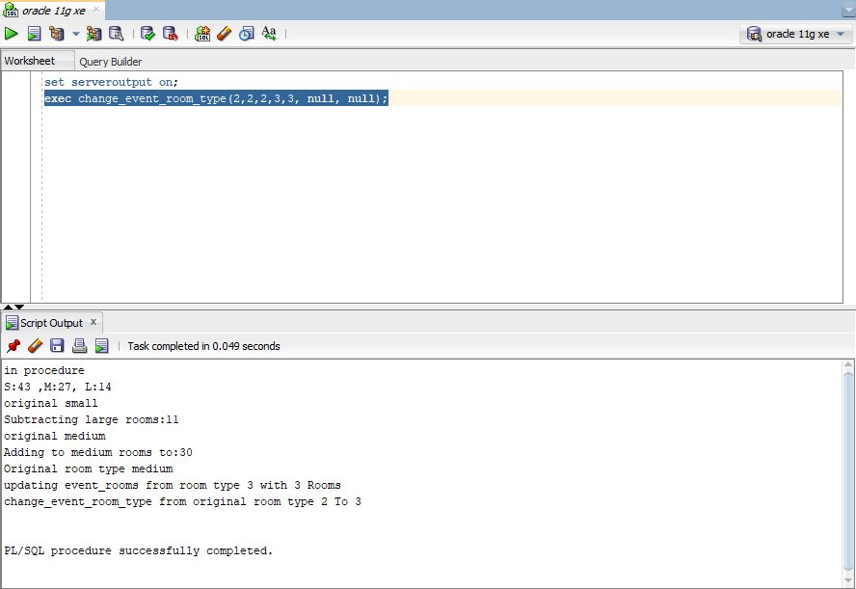

**3.4**

1. **Code**

------------------------------------------------------------------------------------------------------------------

--code 3.2

--Author: Priyanka Ranade

--Calculates and displays total income from all sources of all hotels given month (integer version) as input

--Totals printed by month, and for each month by event and service type, and if no events, shows appropriate output

--implicit cursor to execute commented out at the end

create or replace function monthly_income_report (v_event_id in integer)

return number is

v_total_return number;

begin

DECLARE

num_guests integer;

num_days integer;

sr integer;

mr integer;

lr integer;

room_total number;

service_id number;

service_total number;

tmp number;

total_discount_percent number;

total_discount_amount number;

hostname varchar(50);

small_room_price number;

medium_room_price number;

large_room_price number;

sd date;

st varchar(50);

numitems number;

sp number;

tpd number;

total_bill number;

total_service number;

v_event_name varchar(50);

cursor c1 is

select service_id from services_for_events where event_reservation_id = v_event_id;

-- cursor to find service total date,

cursor c2 is

select service_date,service_type, num_event_items,service_price,

(num_event_items * service_price) as service_total_per_day

from services_for_events, services

where services_for_events.service_id = services.service_id

and event_reservation_id = v_event_id;

begin

num_days := get_event_duration (v_event_id);

dbms_output.put_line('Creating bill for eventid:' || v_event_id);

-- Get event name ----

select event_name into v_event_name from event_type, event_reservation

where event_reservation.event_id=event_type.event_id and event_reservation.event_reservation_id = v_event_id;

dbms_output.put_line('event type:' || v_event_name);

-- Event room number(s), rate per day and possibly multiple rooms

-- (if someone reserved several rooms)

select num_small_rooms, num_medium_rooms, num_large_rooms into sr, mr, lr from event_reservation

where event_reservation_id = v_event_id ;

-- Get the rate per day for each room type

select room_price into small_room_price from room_type

where room_id =1;

select room_price into medium_room_price from room_type

where room_id =2;

select room_price into large_room_price from room_type

where room_id =3;

-- find room total

room_total :=0;

select num_of_guests, num_small_rooms, num_medium_rooms, num_large_rooms into num_guests, sr, mr, lr from event_reservation where event_reservation_id = get_event_duration (2);

-- dbms_output.put_line('small rooms ' || sr || ', medium ' || mr || ' large ' || lr);

room_total := (room_charge(num_days,1) * sr) + (room_charge(num_days,2) * mr ) + (room_charge(num_days, 3) * lr);

--dbms_output.put_line('room total:' || Room_total);

-- Get service by day

-- Services rendered per date, type, and amount

total_bill := 0;

total_service := 0;

open c2;

loop

fetch c2 into sd, st, numitems, sp, tpd;

EXIT WHEN c2%notfound;

dbms_output.put_line('service date:' ||sd || ', Service Type:' || st || ', number of items:' || numitems || ' ,service price $' || sp || ', Total price per day:$' ||tpd );

total_service:= total_service + tpd;

end loop;

close c2;

service_total :=0;

open c1;

-- get event duration

loop

fetch c1 into service_id ;

EXIT WHEN c1%notfound;

-- dbms_output.put_line(' service id====:' || service_id);

-- calculate service charge for service id

service_total := service_total + service_charge(10 ,service_id);

-- dbms_output.put_line('service total:' || service_total);

end loop;

close c1;

dbms_output.put_line('Service Total:$' ||total_service);

total_discount_percent := get_discount (v_event_id);

dbms_output.put_line('Discount applied:' || total_discount_percent || '%');

-- calculate discount amoutn

-- find out if need to give discount

total_discount_percent := get_discount (v_event_id);

if total_discount_percent > 0

then

total_discount_amount:=room_total *(total_discount_percent/100);

room_total:= room_total - total_discount_amount;

dbms_output.put_line('Discount amount:' || total_discount_amount);

dbms_output.put_line('Room charge after discountt:' || room_total);

end if;

total_bill := room_total + total_service;

dbms_output.put_line('Bill After Discount:$' || total_bill);

v_total_return :=0;

v_total_return:= total_bill;

end;

return v_total_return;

end;

--declare

--x number;

--begin

--x:=monthly_income_report (2);

--end;

**2. Screenshot of Output**

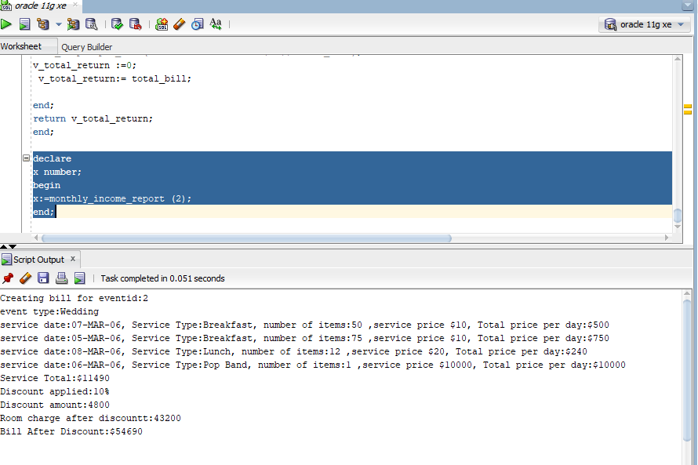

**3.5**

1. **Code**

--loops through month and calls monthly_bill_for_event

create or replace procedure monthly_income ( v_month in integer)

is

l_cursor SYS_REFCURSOR;

y integer;

x number;

monthname varchar(50);

begin

l_cursor:=get_events(v_month);

SELECT TO_CHAR(TO_DATE(v_month, 'MM'), 'MONTH') into monthname FROM DUAL;

loop

fetch l_cursor into y;

IF l_cursor%RowCount = 0 then

dbms_output.put_line('no data found for this month: ' || monthname);

end if;

EXIT WHEN l_cursor%NOTFOUND;

-- get monthly bill

x:=0;

x := monthly_bill_for_event(y);

dbms_output.put_line('Total bill:' || x);

end loop;

close l_cursor;

end;

**--monthly_bill_for_event**

--adds room prices and services for events in a month

create or replace function monthly_bill_for_event (v_event_id in integer)

return number is

v_total_return number;

begin

DECLARE

num_guests integer;

num_days integer;

sr integer;

mr integer;

lr integer;

room_total number;

service_id number;

service_total number;

tmp number;

total_discount_percent number;

total_discount_amount number;

hostname varchar(50);

small_room_price number;

medium_room_price number;

large_room_price number;

sd date;

st varchar(50);

numitems number;

sp number;

tpd number;

total_bill number;

total_service number;

v_event_name varchar(50);

cursor c1 is

select service_id from services_for_events where event_reservation_id = v_event_id;

-- cursor to find service total date,

cursor c2 is

select service_date,service_type, num_event_items,service_price,

(num_event_items * service_price) as service_total_per_day

from services_for_events, services

where services_for_events.service_id = services.service_id

and event_reservation_id = v_event_id;

begin

num_days := get_event_duration (v_event_id);

dbms_output.put_line('Creating bill for eventid:' || v_event_id);

-- Get event name ----

select event_name into v_event_name from event_type, event_reservation

where event_reservation.event_id=event_type.event_id and event_reservation.event_reservation_id = v_event_id;

dbms_output.put_line('event type:' || v_event_name);

-- Event room number(s), rate per day and possibly multiple rooms

-- (if someone reserved several rooms)

select num_small_rooms, num_medium_rooms, num_large_rooms into sr, mr, lr from event_reservation

where event_reservation_id = v_event_id ;

-- Get the rate per day for each room type

select room_price into small_room_price from room_type

where room_id =1;

select room_price into medium_room_price from room_type

where room_id =2;

select room_price into large_room_price from room_type

where room_id =3;

-- find room total

room_total :=0;

select num_of_guests, num_small_rooms, num_medium_rooms, num_large_rooms into num_guests, sr, mr, lr from event_reservation where event_reservation_id = get_event_duration (2);

-- dbms_output.put_line('small rooms ' || sr || ', medium ' || mr || ' large ' || lr);

room_total := (room_charge(num_days,1) * sr) + (room_charge(num_days,2) * mr ) + (room_charge(num_days, 3) * lr);

--dbms_output.put_line('room total:' || Room_total);

-- Get service by day

-- Services rendered per date, type, and amount

total_bill := 0;

total_service := 0;

open c2;

loop

fetch c2 into sd, st, numitems, sp, tpd;

EXIT WHEN c2%notfound;

dbms_output.put_line('service date:' ||sd || ', Service Type:' || st || ', number of items:' || numitems || ' ,service price $' || sp || ', Total price per day:$' ||tpd );

total_service:= total_service + tpd;

end loop;

close c2;

service_total :=0;

open c1;

-- get event duration

loop

fetch c1 into service_id ;

EXIT WHEN c1%notfound;

-- dbms_output.put_line(' service id====:' || service_id);

-- calculate service charge for service id

service_total := service_total + service_charge(10 ,service_id);

-- dbms_output.put_line('service total:' || service_total);

end loop;

close c1;

dbms_output.put_line('Service Total:$' ||total_service);

total_discount_percent := get_discount (v_event_id);

dbms_output.put_line('Discount applied:' || total_discount_percent || '%');

-- calculate discount amoutn

-- find out if need to give discount

total_discount_percent := get_discount (v_event_id);

if total_discount_percent > 0

then

total_discount_amount:=room_total *(total_discount_percent/100);

room_total:= room_total - total_discount_amount;

dbms_output.put_line('Discount amount:' || total_discount_amount);

dbms_output.put_line('Room charge after discountt:' || room_total);

end if;

total_bill := room_total + total_service;

dbms_output.put_line('Bill After Discount:$' || total_bill);

v_total_return :=0;

v_total_return:= total_bill;

end;

return v_total_return;

end;

--MAIN FILE--execute code above at once.

--loops through each month and calculates event expenses as expressed in code above.

--exec statement commented out at end of file

create or replace procedure execute_monthly_invoice as

monthname varchar(50);

begin

for mnt in 1..12 loop

SELECT TO_CHAR(TO_DATE(mnt, 'MM'), 'MONTH') into monthname FROM DUAL;

dbms_output.put_line('Creating monthly income for:' || monthname );

dbms_output.put_line('' );

monthly_income(mnt);

end loop;

End;

--exec execute_monthly_invoice;

1. **Screenshots of Output**

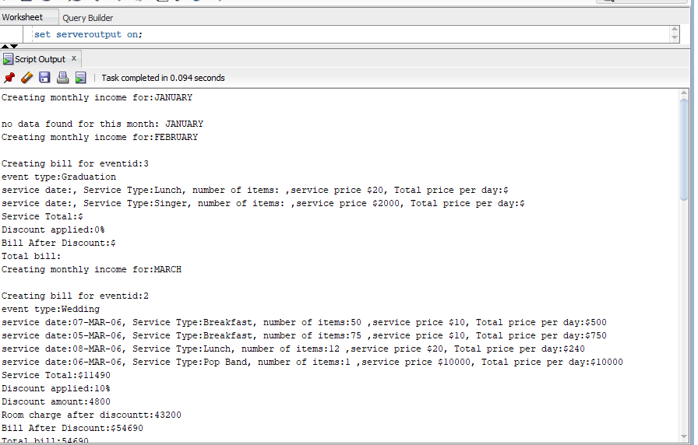

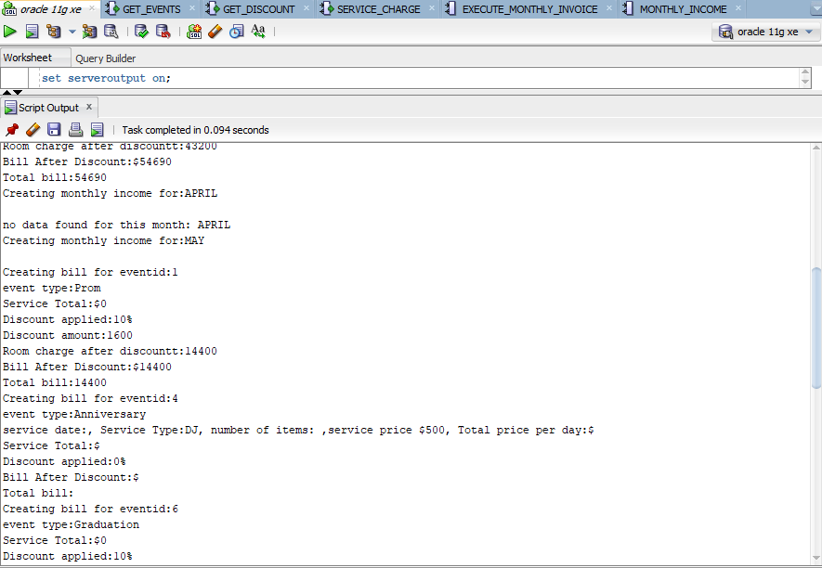

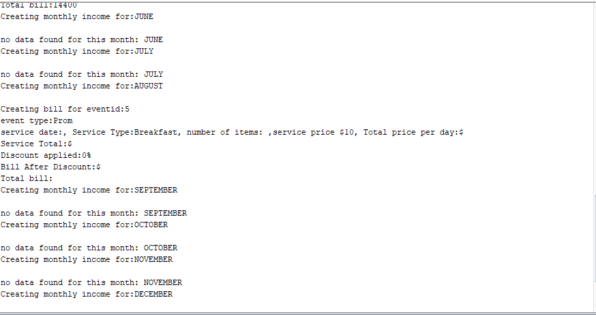

**----------------------------------------------------------------------------------------------------------------**

Solution 17:

set serveroutput on;

create or replace procedure service_to_an_event

(

eventreservationid in event_reservation.event_reservation_id%type,

specificservice in services.service_type%type,

serv_date in date

)

is

var_serv services%rowtype;

service_type varchar(100);

tot_amt number;

no_of_people int;

begin

select service_id, service_type, service_price, per_person_or_event

into var_serv

from services

where service_type = specificservice;

select num_of_guests

into no_of_people

from event_reservation

where event_reservation_id=eventreservationid;

if(var_serv.per_person_or_event = 'person')then

tot_amt := no_of_people * var_serv.service_price;

elsif(var_serv.per_person_or_event = 'event')then

tot_amt := var_serv.service_price;

else

dbms_output.put_line('invalid service');

end if;

if(specificservice = 'Breakfast') then

insert into services_for_events values (eventreservationid, var_serv.service_id, serv_date, no_of_people, tot_amt);

elsif (specificservice = 'Lunch') then

insert into services_for_events values (eventreservationid, var_serv.service_id, serv_date, no_of_people, tot_amt);

else

insert into services_for_events values (eventreservationid, var_serv.service_id, serv_date, 1, tot_amt);

end if;

end;

exec service_to_an_event(1,’Breakfast’,to_date('04-MAY-06','DD-MON-YY'));

Solution 20:

CREATE OR REPLACE PROCEDURE services_income_report(HID IN hotel.Hotel_ID%TYPE)

IS

CURSOR c1 IS select sum(total) from services_for_events,event_reservation,hotel

where services_for_events.event_reservation_ID = event_reservation.event_reservation_ID

and hotel.hotel_id=event_reservation.hotel_ID and hotel.Hotel_ID=HID;

Services_Amount float;

BEGIN

OPEN c1;

LOOP

FETCH c1 into Services_Amount;

EXIT WHEN c1%NOTFOUND;

DBMS_OUTPUT.PUT_LINE('total amount for the services in the given hotel is :' ||Services_Amount);

END LOOP;

close c1;

--Handling the exception ---

EXCEPTION

WHEN no_data_found THEN

DBMS_OUTPUT.PUT_LINE('Total services amount cannot be calculated for the given hotel !');

END;

exec services_income_report();

create or replace PROCEDURE services_income_report(HID IN hotel.Hotel_ID%TYPE)

IS

CURSOR c1 IS select sum(total) from services_for_events,event_reservation,hotel

where services_for_events.event_reservation_ID = event_reservation.event_reservation_ID

and hotel.hotel_id=event_reservation.hotel_ID and hotel.Hotel_ID=HID;

Services_Amount float;

BEGIN

select sum(total)

into Services_Amount

from services_for_events,event_reservation,hotel

where services_for_events.event_reservation_ID = event_reservation.event_reservation_ID

and hotel.hotel_id=event_reservation.hotel_ID and hotel.Hotel_ID=HID;

DBMS_OUTPUT.PUT_LINE('total amount for the services in the given hotel is :' ||Services_Amount);

--OPEN c1;

--LOOP

-- FETCH c1 into Services_Amount;

-- EXIT WHEN c1%NOTFOUND;

-- DBMS_OUTPUT.PUT_LINE('total amount for the services in the given hotel is :' ||Services_Amount);

--END LOOP;

--close c1;

--Handling the exception ---

EXCEPTION

WHEN no_data_found THEN

DBMS_OUTPUT.PUT_LINE('Total services amount cannot be calculated for the given hotel !');

END;

Solution 21:

create or replace FUNCTION get_events_in_state(h_ID in integer)

RETURN SYS_REFCURSOR

AS

my_cursor SYS_REFCURSOR;

BEGIN

OPEN my_cursor FOR select event_reservation_id from event_reservation

where hotel_ID= h_ID;

RETURN my_cursor;

END;

select get_events_in_state (1)

from dual;

create or replace procedure income_per_state ( v_h_ID in integer)

is

l_cursor SYS_REFCURSOR;

y integer;

x number;

h_ID varchar(50);

state_name varchar(50);

begin

l_cursor:=get_events_in_state(v_h_ID);

SELECT v_h_ID into h_ID FROM DUAL;

select state into state_name from hotel , event_reservation

where event_reservation.hotel_id = hotel.hotel_ID and hotel.hotel_ID=h_ID;

loop

fetch l_cursor into y;

IF l_cursor%RowCount = 0 then

dbms_output.put_line('no data found for this state: ' || state_name );

end if;

EXIT WHEN l_cursor%NOTFOUND;

-- get monthly bill

x:=0;

x := monthly_bill_for_event(y);

dbms_output.put_line('Total bill:' || x);

end loop;

close l_cursor;

end;